Why are people wearing masks?
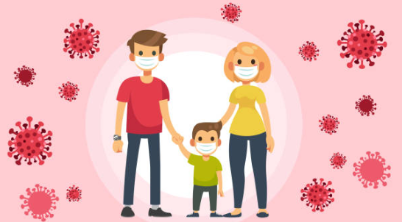

Created by Claire Fitzhenry, Student Speech and Language Therapist, under the supervision of Michelle O’Donoghue, SLT, CORU reg 018688

How to use a social story™

Social stories™ are short, simple stories that help people to understand what is going on (Gray 2010).

During this pandemic, there has been a lot of change. Social stories are very helpful to understand some of these changes.

Follow these steps when using this social story:

- Read this story with your child when they are struggling to understand why so many people are wearing masks. It may help to read the story just before you go outside with your child.

- When possible read this story to your child in a quiet and calm environment.

- Tell your child what you will do, e.g. “This story is about why people are wearing masks. Let's read it together”.

- Maintain a positive, reassuring and patient attitude when reviewing the story.

- Review the story as often as required - some social stories will be reviewed once a day, others just before the situation for which they were written.

- As your child gets used to the new situation and the story no longer seems necessary, you can phase out the story. For example, you can read it only when your child is having difficulty understanding why people are wearing masks to refresh their memory.

- It is a good idea to personalise this social story. You can customise any picture or text in the social story as long as the message remains consistent

We hope that you enjoy using this social story.

Reference: Gray, C. (2010) The New Social Story™ Book, Future Horizons: Texas.

Why are people wearing masks?
Lots of people are wearing masks lately. They are wearing masks to protect themselves against germs. | 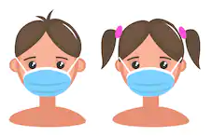
Germs can make you sick if they get into your nose or mouth.
Masks help keep you safe and healthy by covering your nose and mouth.

People wear masks when they go outside. | 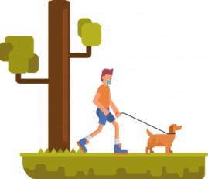
People wear masks when they go other places too, like to the shops. | 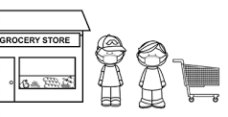
It might be scary to see people wearing masks, because you cannot see their face or mouth. | 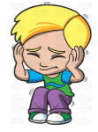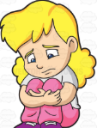
The person wearing a mask is trying to keep themselves safe and healthy. This helps to keep you safe and healthy too. | 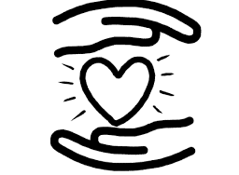
It helps if you imagine the person wearing the mask is smiling. | 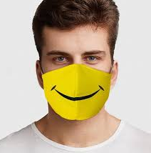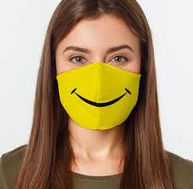
Even though things are different at the minute, people are still happy to see me. | 