Using Hand Sanitiser
What is it?

Why do you use it?

Hand sanitiser is something we put on our hands  and can look like this. | 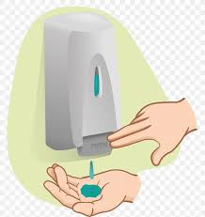  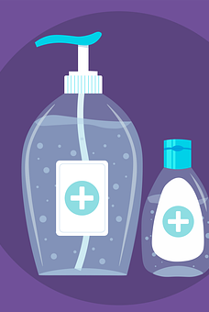

It helps to get rid of germs that are on our hands  and can make us sick. | 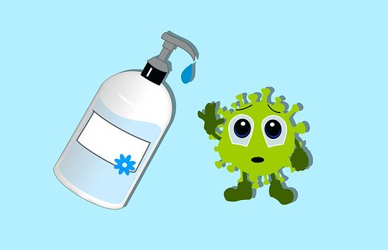
Where do you use it?

\

If you are not near a bathroom, or at home, you can use hand sanitiser to clean your hands. | 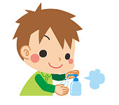
How do you use it?

7.

Make sure there is NO dirt on your hands.
Roll up your sleeves.
Put on enough hand sanitiser to spread over your hands and wrists.

Rub your hands together with the hand sanitiser. | 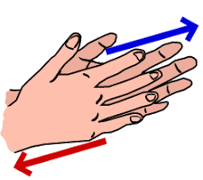
Rub all over the  top of your hands,  each finger, thumb  and under your fingernails. | 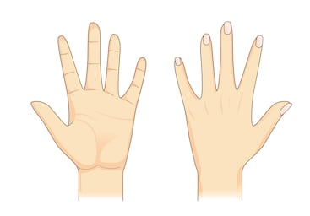
Continue rubbing until your hands feel dry for at least  6.  20 seconds. | 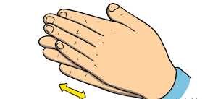
Do NOT
rinse your hands with water
or dry them
afterwards.

Why is it important?

To protect us from getting sick,  we must wash our hands and use hand sanitiser more often. | 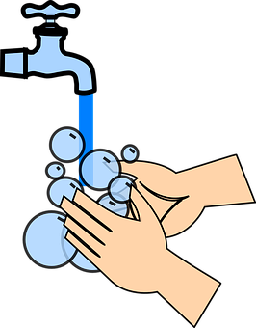
Where can you keep it?

You can carry hand sanitiser in your pocket,  or in your bag  and use it when you are  outside | 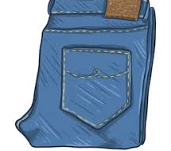

When
should you use it?

You should use hand sanitiser when you enter and leave a place that is not your house.  When you... | - Go to the supermarket  - Go to the playground  - Use a bus or train

Don’t forget!

If you are near a sink,
wash your hands
using soap and water.
Do NOT touch your mouth or face.
Stay more than 2m away from other people when outside. | 2m

Created by Jane Fitzpatrick, Student Speech and Language Therapist, under the supervision of Michelle O’Donoghue, SLT, CORU reg 018688

How to use a social story™

Social stories™ are short, simple stories that help people to understand what is going on (Gray 2010).

During this pandemic, there has been a lot of change. Social stories are very helpful to understand some of these changes.

Follow these steps when using this social story:

- Read this story before leaving your house to go to a public place.

- When possible read this story to your child in a quiet and calm environment.

- Tell your child what you will do, e.g. “This story is about using hand sanitiser. Let's read it together”.

- Maintain a positive, reassuring and patient attitude when reviewing the story.

- Review the story as often as required - some social stories will be reviewed once a day, others just before the situation for which they were written.

- As your child gets used to the new situation and the story no longer seems necessary, you can phase out the story. For example, you can read it only when your child is having difficulty understanding why it is important to use hand sanitiser to refresh their memory.

- It is a good idea to personalise this social story. The following are examples of how you can do this:
  - Pg. 4- Include places that your child likes to go and include pictures of that place
  - Change the colour of the background on each page to your child’s favourite colour
  - You can customize any page in the social story as long as the message remains consistent

We hope that you enjoy using this social story.

Reference: Gray, C. (2010) The New Social Story™ Book, Future Horizons: Texas.

