A Guide to Using Hand Sanitiser
What is it?

Why do you use it?

Hand sanitiser is a liquid, gel or foam. | 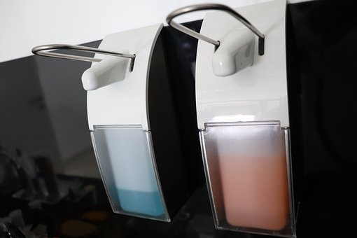  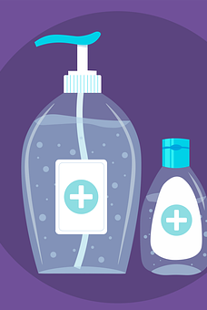

It reduces the amount of germs that are on our hands. | 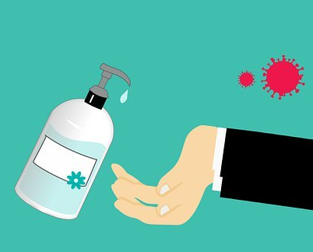  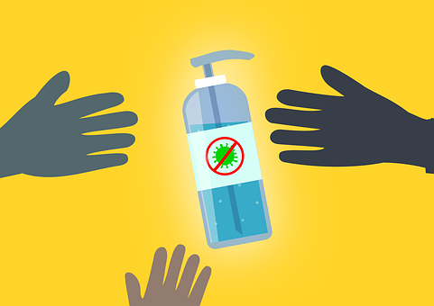

Where do you use it?

If you are not near a bathroom, or at home, you can use hand sanitiser to clean your hands. | 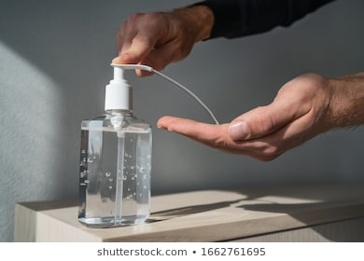

How do you use it?

7.

Make sure there is NO dirt on your hands. | 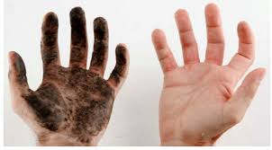
Roll up your sleeves.
Put on enough hand sanitiser to spread over your hands and wrists. | 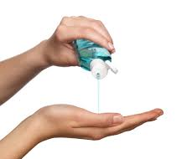
Rub your hands together with the hand sanitiser. | 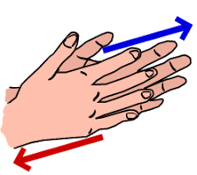
Rub all over the  top of your hands,  in between each finger, thumb  and under your fingernails. | 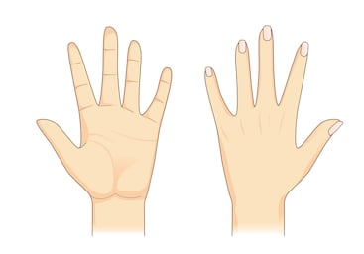
Continue rubbing until your hands feel dry for at least  6.  20 seconds. | 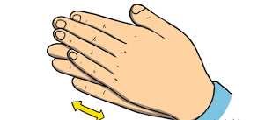
Do NOT  rinse your hands with water  or dry them  afterwards. | 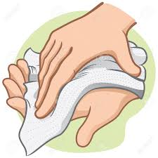

Why is it
important?

To protect us from getting COVID-19/ Coronavirus,  we must wash our hands and use hand sanitiser more often. | 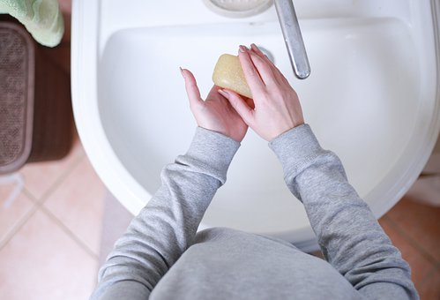

Which one should you buy?

The hand sanitiser should have at least 60% alcohol. | Label
Where can you keep it?

You can carry hand sanitiser in your pocket,  or in your bag  and use it when you are  outside | 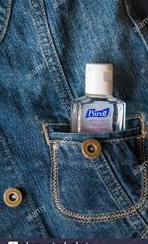

When
should you use it?

You should use hand sanitiser when you enter and leave a public place.  When you... | - Go to the supermarket  - Go to the chemist  - Use public transport
Don’t forget!

If you are near a sink,  wash your hands  using soap and water. | 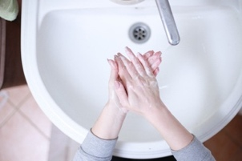
Do NOT touch your mouth or face.
Stay more than 2m away from other people when outside. | 2m

Where you can
buy it?

You can buy
hand sanitiser
at the chemist or in the
supermarket.

Don’t worry if it’s sold out.  Soap and water  work just as well! | 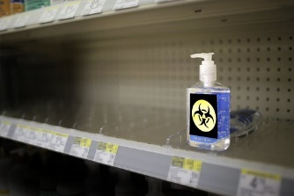

Created by Jane Fitzpatrick, Student Speech and Language Therapist, under the supervision of Michelle O’Donoghue, SLT, CORU reg 018688

How to use a social story™

Social stories™ are short, simple stories that help people to understand what is going on (Gray 2010).

During this pandemic, there has been a lot of change. Social stories are very helpful to understand some of these changes.

Follow these steps when using this social story:

- Read this story before leaving your house to go to a public place.

- When possible read this story in a quiet and calm environment.

- Review the story as often as required - some social stories will be reviewed once a day, others just before the situation for which they were written.

- As you get used to the new situation and the story no longer seems necessary, you can phase out the story. For example, you can read it only when you are having difficulty understanding why you need to use hand sanitiser to refresh your memory.

- It is a good idea to personalise this social story. The following are examples of how you can do this:
  - Pg. 4- Include places that you like to go and include pictures of that place
  - Change the colour of the background on each page to your favourite colour
  - You can customize any page in the social story as long as the message remains consistent

We hope that you enjoy using this social story.

Reference: Gray, C. (2010) The New Social Story™ Book, Future Horizons: Texas.

