Talking to the Gardaí: advice during COVID-19
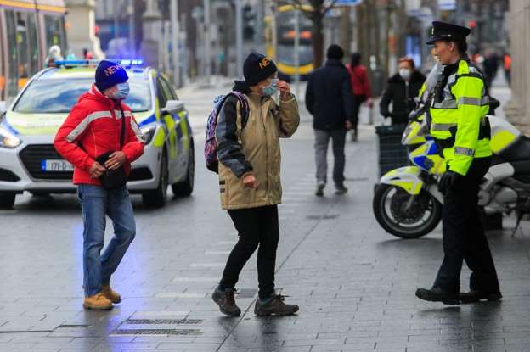
Created by Lora-Jane Gillen, Student Speech and Language Therapist, under the supervision of Michelle O’Donoghue, SLT, CORU reg 018688

How to use a social story™

Social stories™ are short, simple stories that help people to understand what is going on (Gray 2010).

During this pandemic, there has been a lot of change. Social stories are very helpful to understand some of these changes.

Follow these steps when using this social story:

- Read this story before you leave your house.

- When possible read this story in a quiet and calm environment.

- Review the story as often as required - some social stories will be reviewed once a day, others just before the situation for which they were written.

- As you get used to the new situation and the story no longer seems necessary, you can phase out the story. For example, you can read it only when you are having difficulty understanding how to talk to Garda when you go outside to refresh your memory.

We hope that you enjoy using this social story.

The coronavirus is a new type of virus or illness.

Some people call it COVID-19.

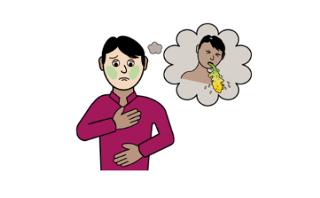 | It can make you very sick.
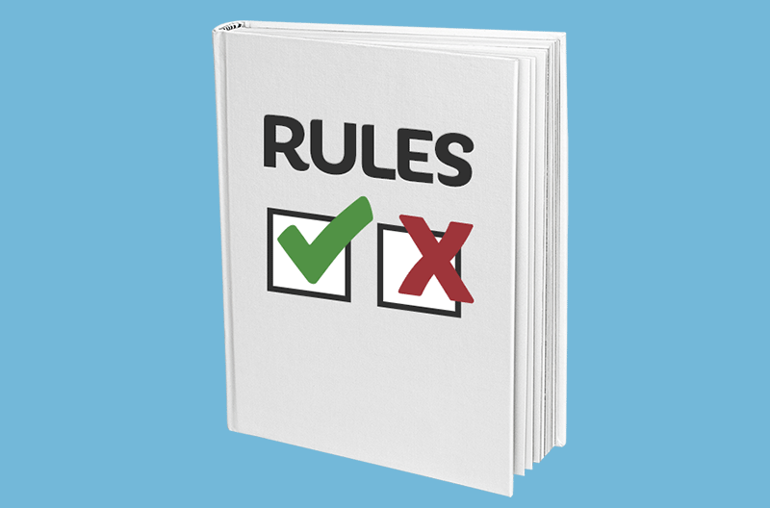 | There are new rules because of the coronavirus.
Rule 1: You can go outside to exercise.

You need to stay within 5 km of your home.
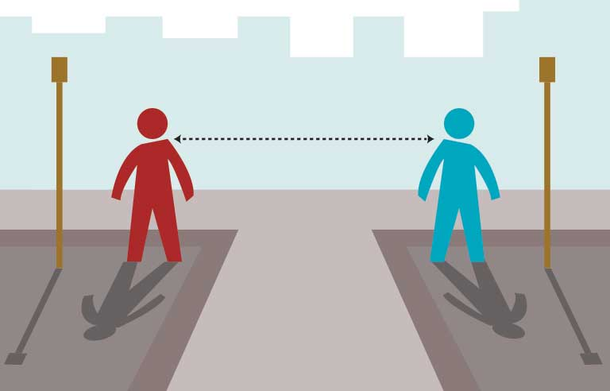 | Rule 2: You need to stay 2 metres away from other people when walking outside.
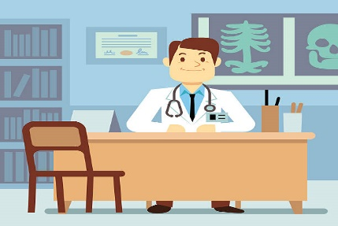  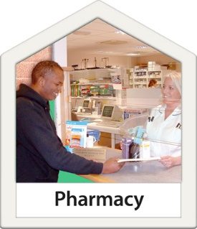 | You can go out for important things like:  - Food  - Medicine  - Doctor Appointments
 | The Gardaí are making sure that people follow the new rules.
 | The Gardaí’s job is to keep everyone safe.
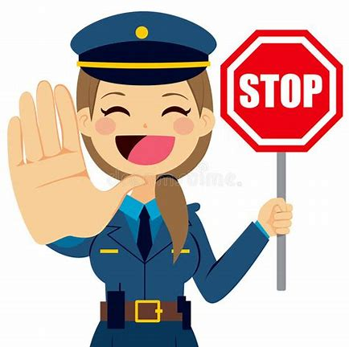 | A Garda might stop you and ask you questions.  You are not in trouble.  You do not need to worry.
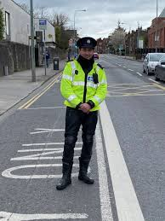 | The Garda might ask you some questions like:  - What are you doing?  - Where do you live?  Answer the Garda’s questions.
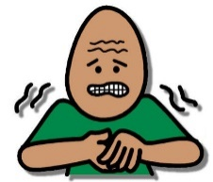 | If you feel stressed, tell the Garda what he or she can do to help you.
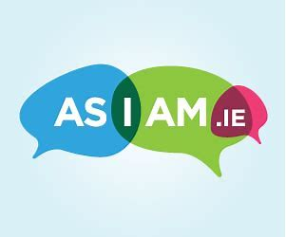 | Show the Garda your letter from AsIAm. It is available to print here.  This letter will help the Garda to understand your needs.
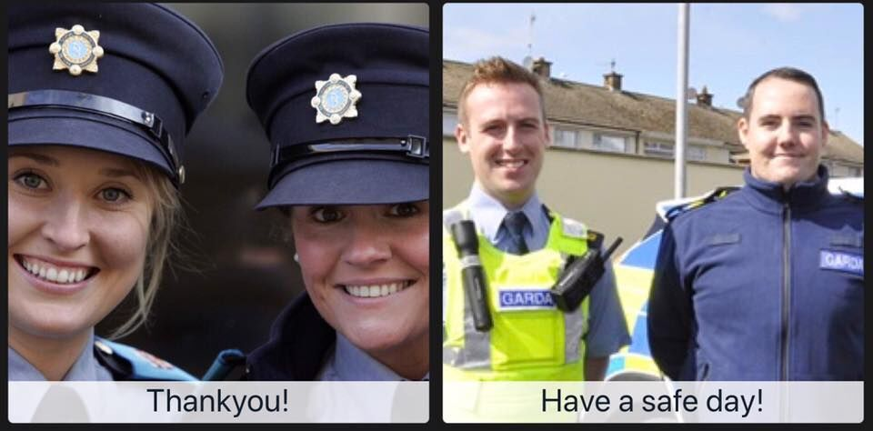 | Remember, the Gardaí are making sure that everyone is following these rules to keep us safe and healthy.

