Stopping at a Garda Checkpoint

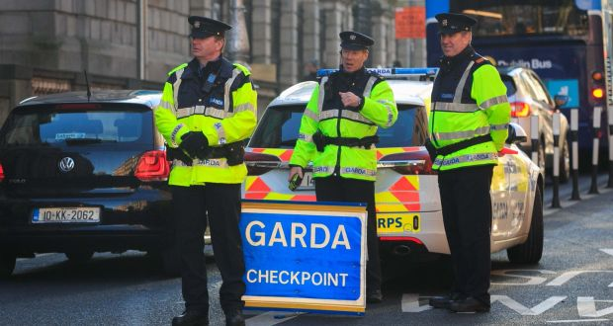

Created by Alisha McMahon, Student Speech and Language Therapist, under the supervision of Michelle O’Donoghue, SLT, CORU reg 018688

How to use a social story™

Social stories™ are short, simple stories that help people to understand what is going on (Gray 2010).

During this pandemic, there has been a lot of change. Social stories are very helpful to understand some of these changes.

Follow these steps when using this social story:

- Read this story before driving.

- When possible read this story in a quiet and calm environment.

- Review the story as often as required - some social stories will be reviewed once a day, others just before the situation for which they were written.

- As you get used to the new situation and the story no longer seems necessary, you can phase out the story. For example, you can read it only if you have difficulty understanding a garda checkpoint to refresh your memory.

- You can customize any page in the social story as long as the message remains consistent.

We hope that you enjoy using this social story.

Reference: Gray, C. (2010) The New Social Story™ Book, Future Horizons: Texas.

There is a new virus called the coronavirus that can make people very sick.

There are new rules to stop the spread of coronavirus and to keep everyone safe. The new rules mean that you can only drive for necessary journeys.

A necessary journey includes driving to the shop to get food.

Or driving to the pharmacy to get medicine.
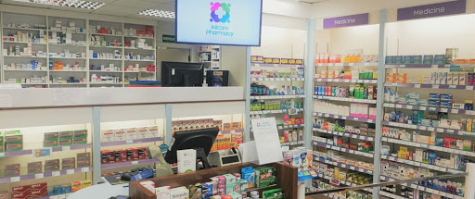

Or driving to see the doctor.
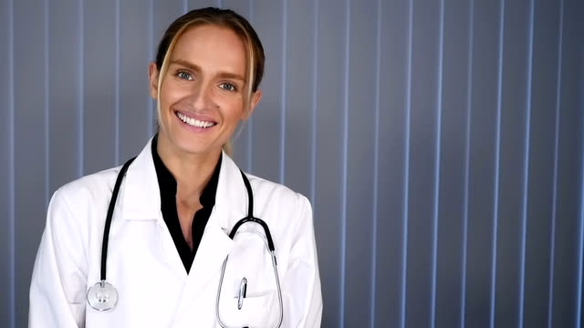

The Minister for Health has said that autistic people can go for a drive for other reasons if needed.
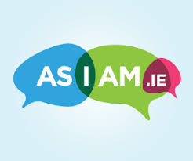
AsIAm have produced a template letter that you can print to show to the Gardaí. It is available here.
You will also need proof of your diagnosis such as a letter from your healthcare provider or assessment report.

The Gardaí have an important job. They want to keep everyone safe. They might stop you to ask some questions to make sure that everyone is following the new rules.
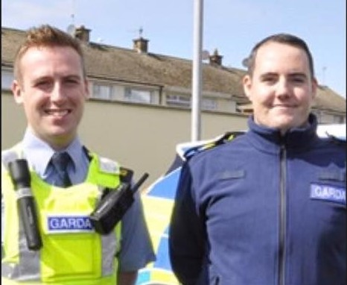

While driving your car you might see cars stopped on the road.
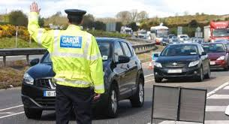
It is a Garda checkpoint.
You are not in trouble.
The Gardaí want to ask questions.
You do not need to worry.

You wait in a queue for your turn to talk to the Garda.

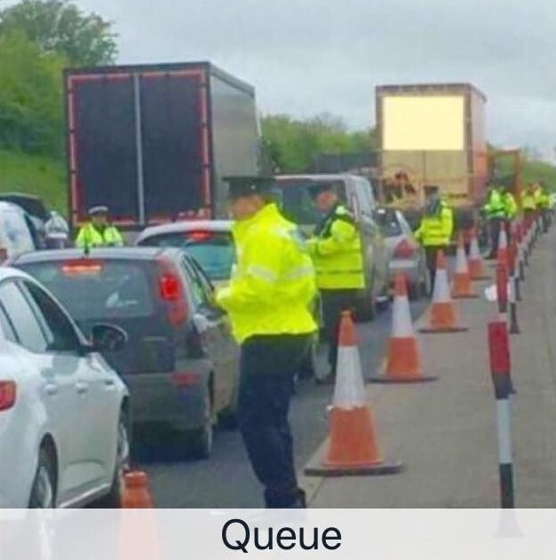

When it is your turn, you put down the window and talk to the Garda.
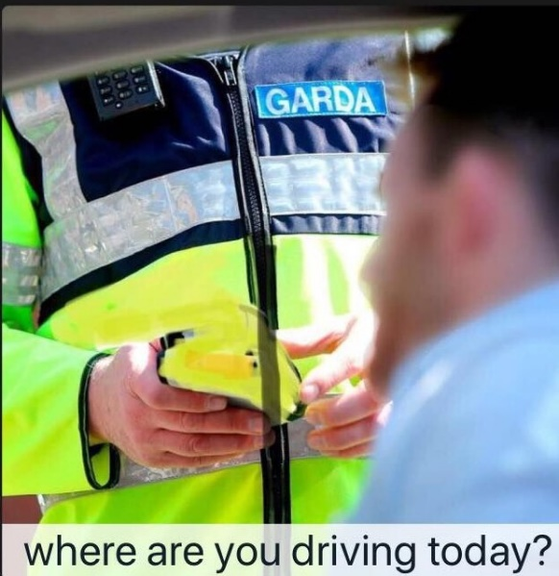
The Garda might ask you where you are going.
The Garda might ask you where you live.
The Garda might ask to see your driving licence.
You should answer the Garda’s questions.

If you feel stressed, you can tell the Garda what they can do to help.

Before you leave home, fill out the form below.
Hand it to the Garda if you find it difficult to answer his or her questions.

My Name is | THIS IS WHAT MY BEHAVIOUR LOOKS LIKE WHEN I AM STRESSED
I LIVE at
Emergency contact person (name and contact details)

my Diagnosis is | THIS CAN HELP TO CALM ME DOWN
how i communicate

When you have answered the Garda’s questions, you drive away and continue on your journey.

