I do my schoolwork at home

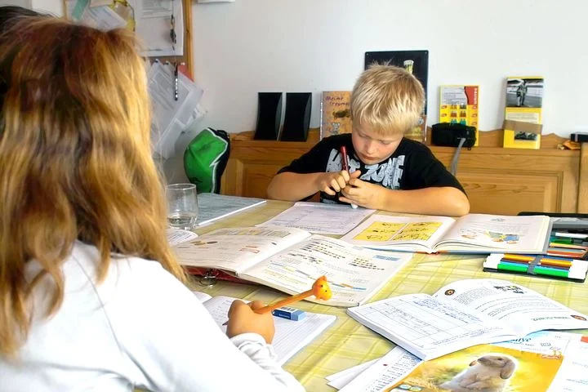
Created by Nicole O’Callaghan, Student Speech and Language Therapist, under the supervision of Michelle O’Donoghue, SLT, CORU reg 018688

How to use a social story™
Social stories™ are short, simple stories that help people to understand what is going on (Gray 2010).
During this pandemic, there has been a lot of change. Social stories are very helpful to understand some of these changes.
Follow these steps when using this social story:
- Read this story before it is time for your child to do their schoolwork.

- When possible read this story to your child in a quiet and calm environment.

- Tell your child what you will do, e.g. “This story is about doing your schoolwork at home. Let's read it together”.

- Maintain a positive, reassuring and patient attitude when reviewing the story.

- Review the story as often as required - some social stories will be reviewed once a day, others just before the situation for which they were written.

- As your child gets used to the new situation and the story no longer seems necessary, you can phase out the story. For example, you can read it only when your child is having difficulty understanding why they cannot do their schoolwork at school, to refresh their memory.

- It is a good idea to personalise this social story. The following are examples of how you can do this:
  - Page 1 – Insert a picture of your child doing their schoolwork
  - Page 6 – Insert a picture of your child’s own visual schedule
  - Page 7 – Insert a picture of a snack they like to eat
  - Insert a picture of your child’s favourite thing onto the pages, e.g. if your child likes dogs then you could add a picture of a dog to each page
  - You can customize any page in the social story as long as the message remains consistent

We hope that you enjoy using this social story.

Reference: Gray, C. (2010) The New Social Story™ Book, Future Horizons: Texas.
There is a new illness in Ireland called the ‘coronavirus’ or ‘COVID-19’.

The coronavirus makes some people very sick.

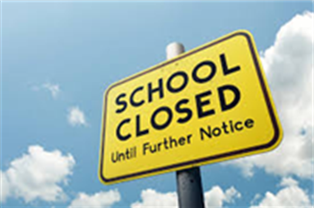

My school needs to close for a while.

This will keep me safe and healthy.

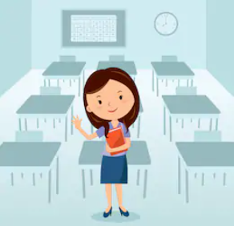

I still need to do my schoolwork at home. This makes my teacher happy.

It keeps my brain working hard!

Monday

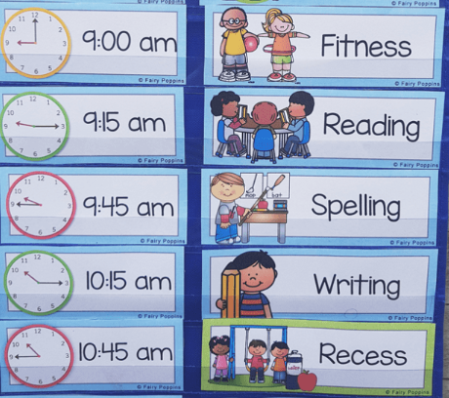

My visual schedule shows me the work I need to do.

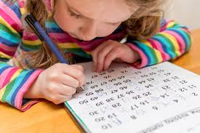

I sit down in a quiet room to do my work.

I take breaks to stretch

I take breaks to get fresh air

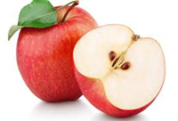

I take breaks to have a snack.

Sometimes I do not understand my schoolwork

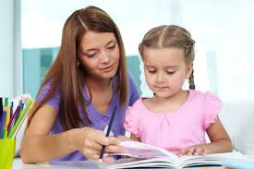

I ask a grown up for help.

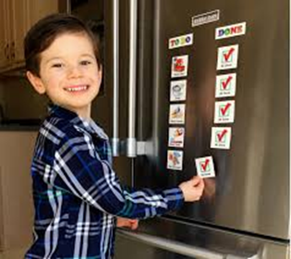

After I finish my schoolwork, I can do other activities!

I do my schoolwork during the week.

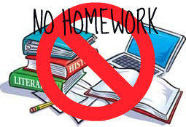

I do not do schoolwork on Saturdays and Sundays.

When schools open again, I will do my schoolwork at school!

