Doing schoolwork at home

Created by Nicole O’Callaghan, Student Speech and Language Therapist, under the supervision of Michelle O’Donoghue, SLT, CORU reg 018688

How to use a social story™

Social stories™ are short, simple stories that help people to understand what is going on (Gray 2010).

During this pandemic, there has been a lot of change. Social stories are very helpful to understand some of these changes.

Follow these steps when using this social story:

- Read this story before it is time to do your schoolwork.

- When possible read this story in a quiet and calm environment.

- Review the story as often as required - some social stories will be reviewed once a day, others just before the situation for which they were written.

- As you get used to the new situation and the story no longer seems necessary, you can phase out the story. For example, you can read it only when you are having difficulty understanding why you cannot do your schoolwork at school, to refresh your memory.

- It is a good idea to personalise this social story. The following are examples of how you can do this:
  - Page 1 – insert picture of yourself doing your homework.
  - Page 9 – insert a picture of your own visual schedule.
  - You can customize any page in the social story as long as the message remains consistent

We hope that you enjoy using this social story.

Reference: Gray, C. (2010) The New Social Story™ Book, Future Horizons: Texas.

There is a new illness in Ireland called the ‘coronavirus’ or ‘COVID-19’.

The coronavirus makes some people very sick.

My school needs to close for a while.

This will keep me safe and healthy.

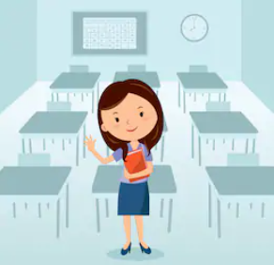

I still need to do my schoolwork at home. This makes my teachers happy.

It keeps my brain working hard!

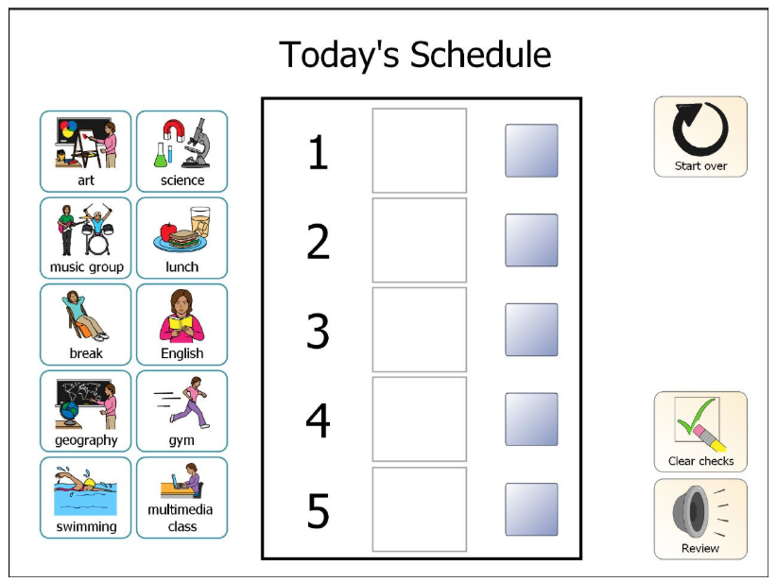

My visual schedule shows me the work that I need to do.

I sit down in a quiet room to do my work.

I take breaks to stretch

I take breaks to get fresh air

I take breaks to have a snack.

Sometimes I do not understand my schoolwork

I ask someone for help.

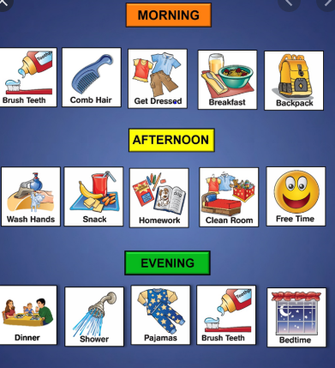

After I finish my schoolwork, I can do other activities!

I do my schoolwork during the week.

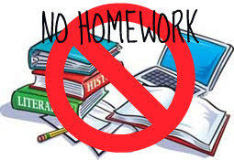

I do not do schoolwork on Saturdays and Sundays.

When schools open again, I will do my schoolwork at school.

