Why are people wearing masks?

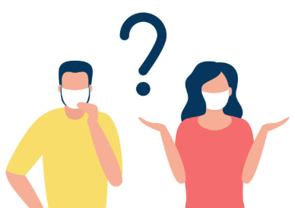
Created by Claire Fitzhenry, Student Speech and Language Therapist, under the supervision of Michelle O’Donoghue, SLT, CORU reg 018688

Created by Nicole O’Callaghan, Student Speech and Language Therapist, under the supervision of Michelle O’Donoghue, SLT, CORU reg 018688
Created by Nicole O’Callaghan, Student Speech and Language Therapist, under the supervision of Michelle O’Donoghue, SLT, CORU reg 018688
Created by Nicole O’Callaghan, Student Speech and Language Therapist, under the supervision of Michelle O’Donoghue, SLT, CORU reg 018688

How to use a social story™

Social stories™ are short, simple stories that help people to understand what is going on (Gray 2010).

During this pandemic, there has been a lot of change. Social stories are very helpful to understand some of these changes.

Follow these steps when using this social story:

- Read this story any time you want to understand why so many people are wearing masks. You may want to read the story before you go outside, to the supermarket or to the doctor.

- When possible read this story in a quiet and calm environment.

- Review the story as often as required - some social stories will be reviewed once a day, others just before the situation for which they were written.

- As you get used to the new situation and the story no longer seems necessary, you can phase out the story. For example, you can read it only when you are having difficulty understanding why people are wearing masks to refresh your memory.

- It is a good idea to personalise this social story. You can customise the text and pictures in the social story as long as the message remains consistent

We hope that you enjoy using this social story.

Reference: Gray, C. (2010) The New Social Story™ Book, Future Horizons: Texas.
Why are people wearing masks?
COVID-19 is a disease which can affect your lungs and airways. | 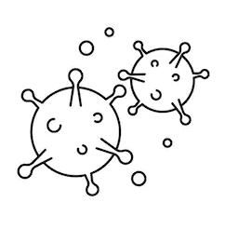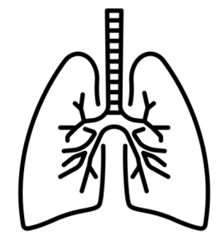
Because of this, lots of people are now wearing masks over their nose and mouth. | 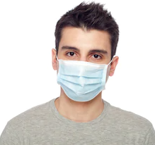
Wearing a mask helps to protect you and others from getting sick. Masks protect against coughing and sneezing. | 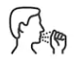
It can be scary or upsetting to see people wearing masks. But the people behind the masks are still friendly. | 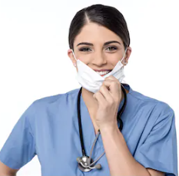
People wear masks when they go outside or to the shops. They do not have to wear masks in their homes. | 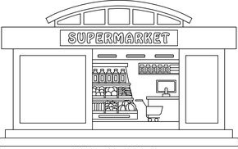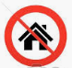
Even though things are different at the minute, people are still happy to see me.

