Going to the supermarket during COVID-19

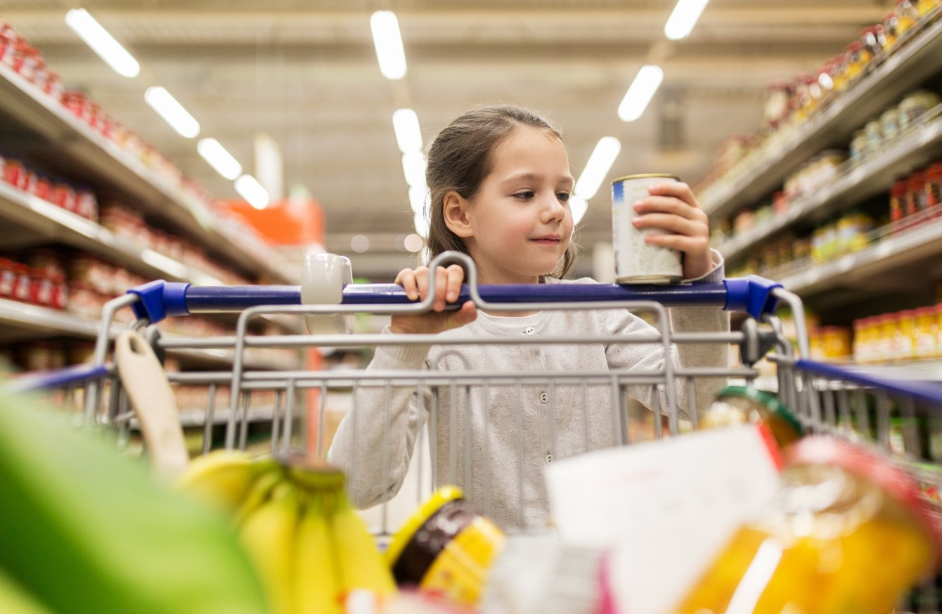

A social story for children.
Created by Jena Cronin, Student Speech and Language Therapist, under the supervision of Michelle O’Donoghue, SLT, CORU reg 018688

How to use a social story™
Social stories™ are short, simple stories that help people to understand what is going on (Gray 2010).
During this pandemic, there has been a lot of change. Social stories are very helpful to understand some of these changes.
Follow these steps when using this social story:
- Read this story with your child before going to the supermarket.
- When possible read this story to your child in a quiet and calm environment.
- Tell your child what you will do, e.g. “This story is about ‘going to the supermarket’. Let's read it together”.
- Maintain a positive, reassuring and patient attitude when reviewing the story.
- Review the story as often as required - some social stories will be reviewed once a day, others just before the situation for which they were written.
- As your child gets used to the new situation and the story no longer seems necessary, you can phase out the story. For example, you can read it only when your child is having difficulty understanding about queuing outside the supermarket for example, to refresh their memory.
- It is a good idea to personalise this social story. The following are examples of how you can do this:
- insert pictures of your child, your family or the supermarket you go to.
- You can customize any page in the social story as long as the message remains consistent.

We hope that you enjoy using this social story.

Reference: Gray, C. (2010) The New Social Story™ Book, Future Horizons: Texas.

Going to the supermarket during COVID-19

There is a new illness in Ireland called ‘COVID-19’ or ‘coronavirus’.

This type of illness can make people very sick.

My family and I must stay away from other people to stop this illness from spreading. This includes when we are in the supermarket.

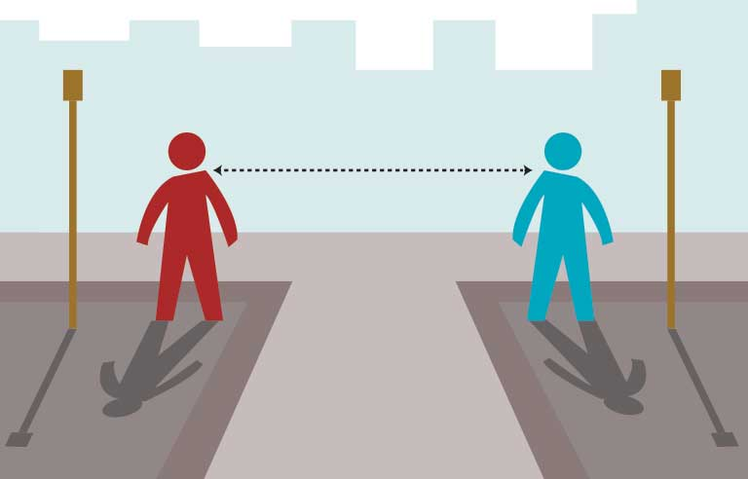

I wash my hands before going to the supermarket.

You can insert a picture of your supermarket here

The supermarket workers will clean the trolleys and baskets.

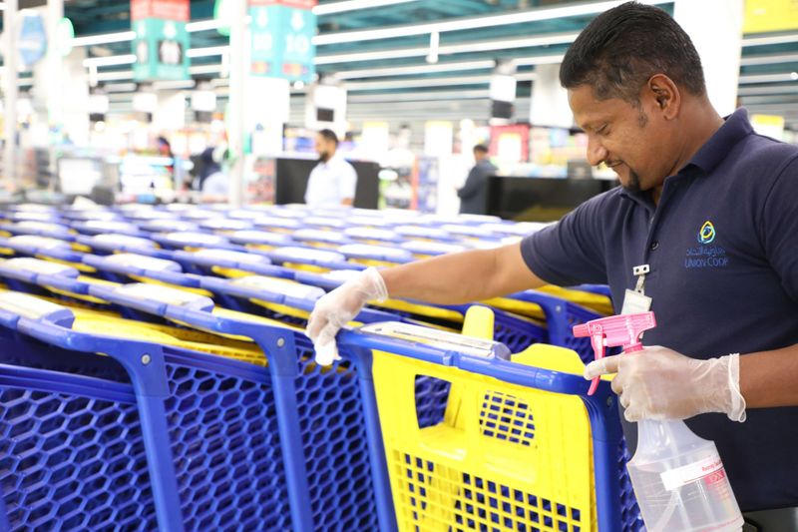

I might wait outside the supermarket before I can go inside. I must stay with a grown up while I wait.
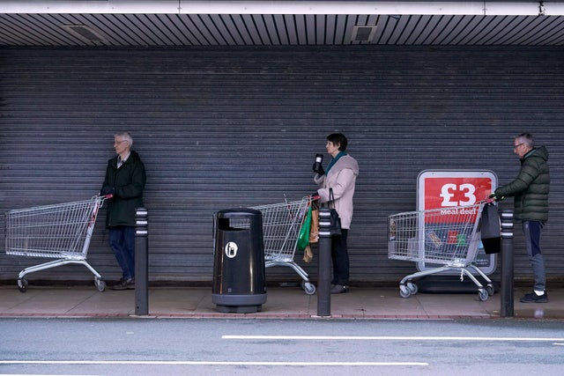
The supermarket worker tells me when it is ok to go into the shop.

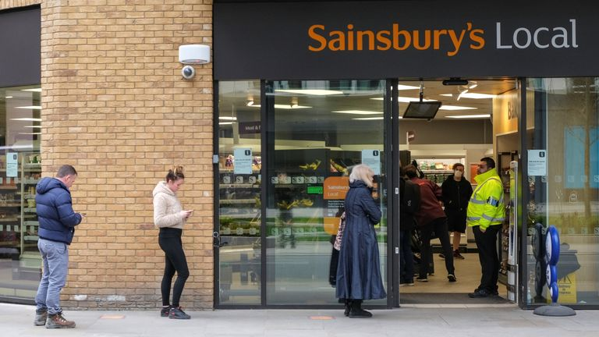

I use hand sanitiser to clean my hands before I go into the shop.

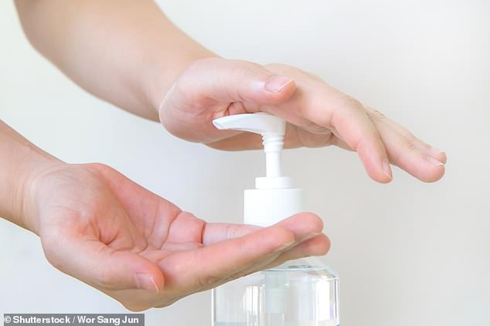

I stay with my grown up in the supermarket. I stay 2 metres away from other people and workers in the shop. The markings on the floor help me.
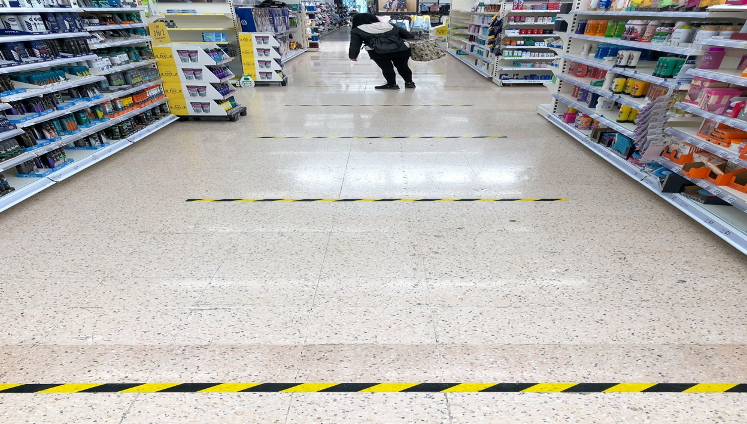

I do not stop to talk to people when I am in the shop.

We wait at the checkout until the checkout worker tells us we can put our groceries on the belt.

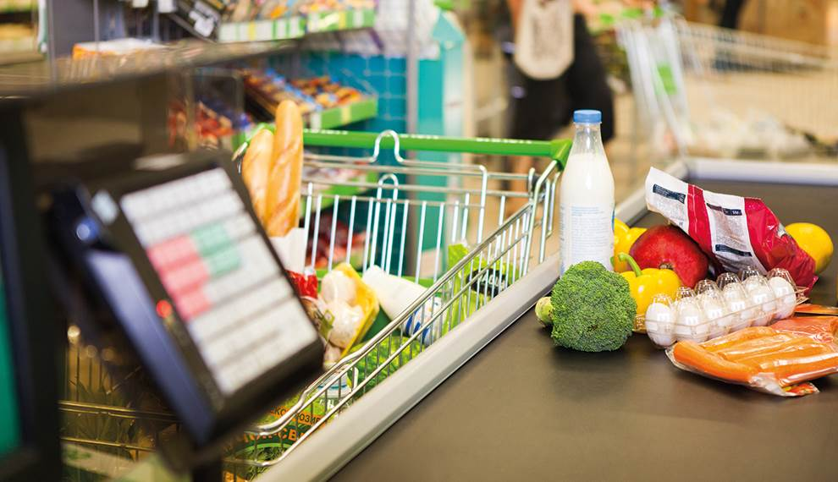

We pack our shopping bags and put them in the car or walk home.
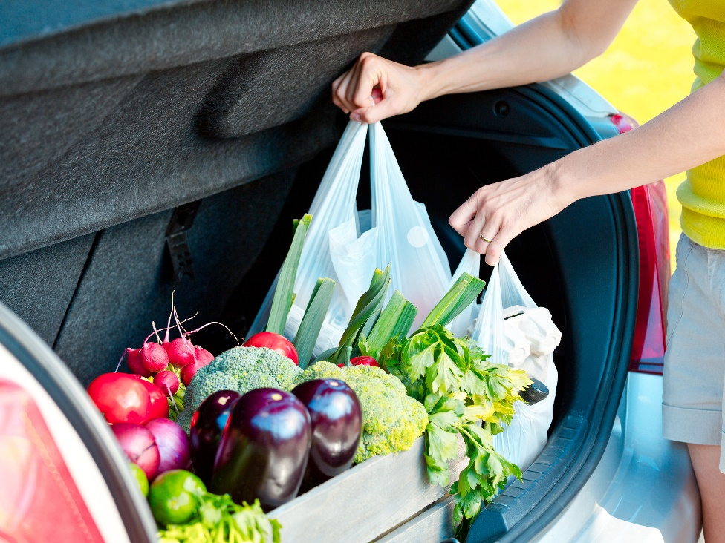
I wash my hands again as soon as I get home.

