Going to the supermarket during COVID-19

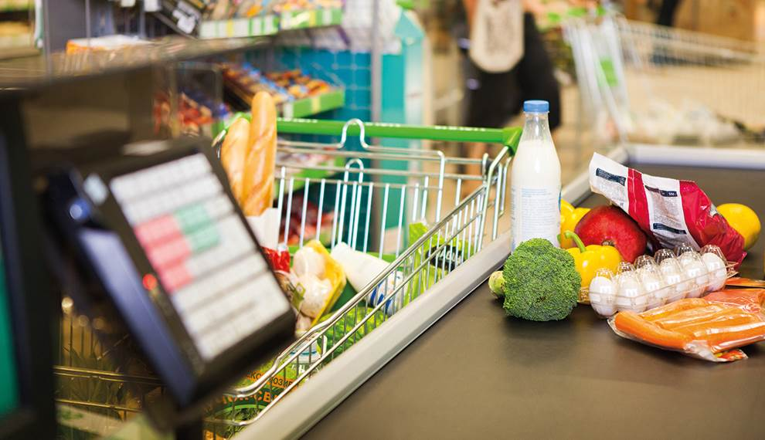
Created by Jena Cronin, Student Speech and Language Therapist, under the supervision of Michelle O’Donoghue, SLT, CORU reg 018688

How to use a social story™

Social stories™ are short, simple stories that help people to understand what is going on (Gray 2010).
During this pandemic, there has been a lot of change. Social stories are very helpful to understand some of these changes.
Follow these steps when using this social story:

- Read this story before going to the supermarket.

- When possible read this story in a quiet and calm environment.

- Review the story as often as required - some social stories will be reviewed once a day, others just before the situation for which they were written.

- As you get used to the new situation and the story no longer seems necessary, you can phase out the story. For example, you can read it only when you are having difficulty understanding something about the supermarket to refresh your memory.

- You can customize any page in the social story as long as the message remains consistent. You might want to insert photos of the supermarket you visit most frequently.

We hope that you enjoy using this social story.
Reference: Gray, C. (2010) The New Social Story™ Book, Future Horizons: Texas.

Going to the supermarket during COVID-19
Going to the supermarket is different now. We need to follow social distancing rules. This lowers to chance of spreading the coronavirus. This guide will tell you what to do when going to the supermarket. Insert a photograph of your local supermarket(s) below.

Going to the supermarket during COVID-19
Wash your hands before you leave the house.

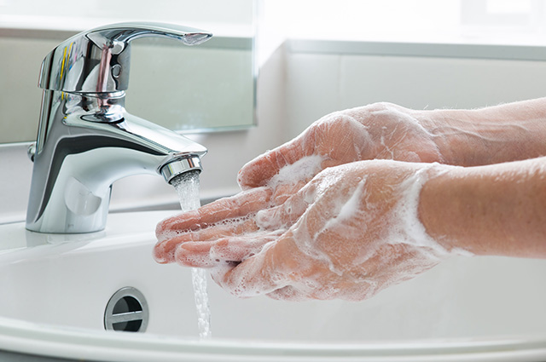

You might need to queue outside the supermarket. Stand 2 metres away from the people in front of and behind you.

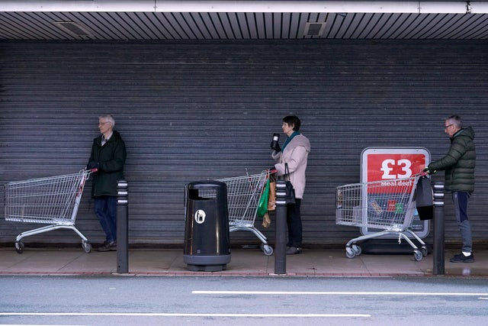

The supermarket workers will clean and sanitise each trolley and basket.
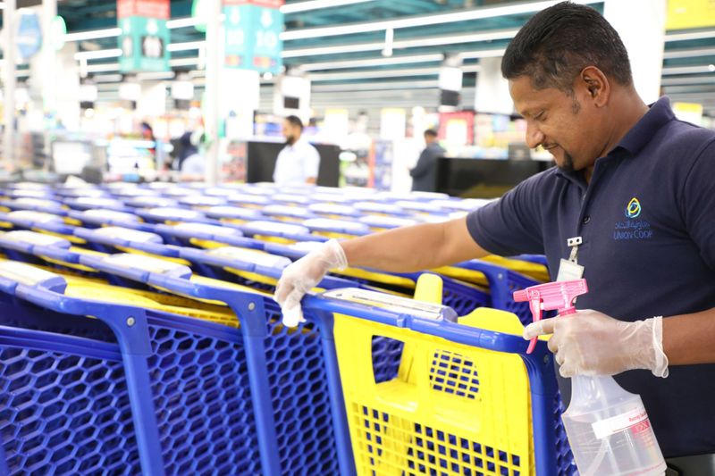

Wait for the supermarket worker to tell you it is ok to go into the shop.
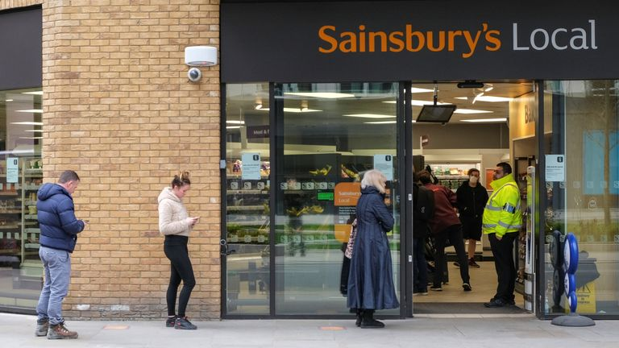

Use hand sanitiser before entering the shop.

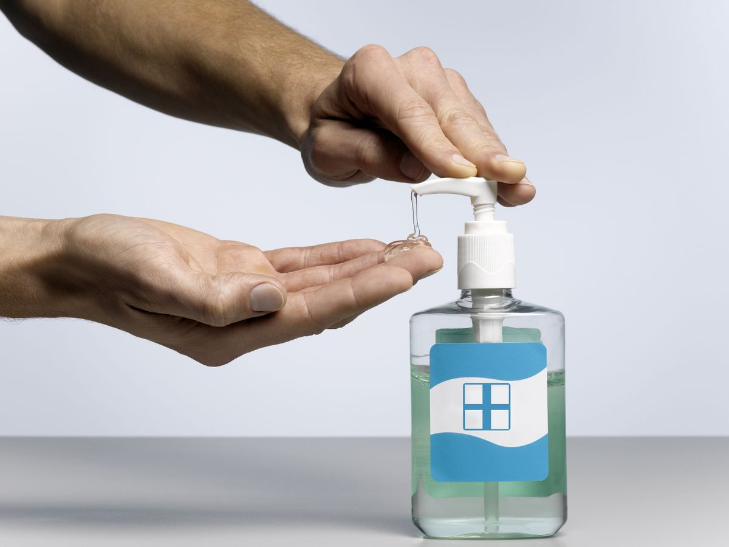

Stay 2 metres away from other people and workers in the shop. Markings on the floor that will help you to keep a safe distance.

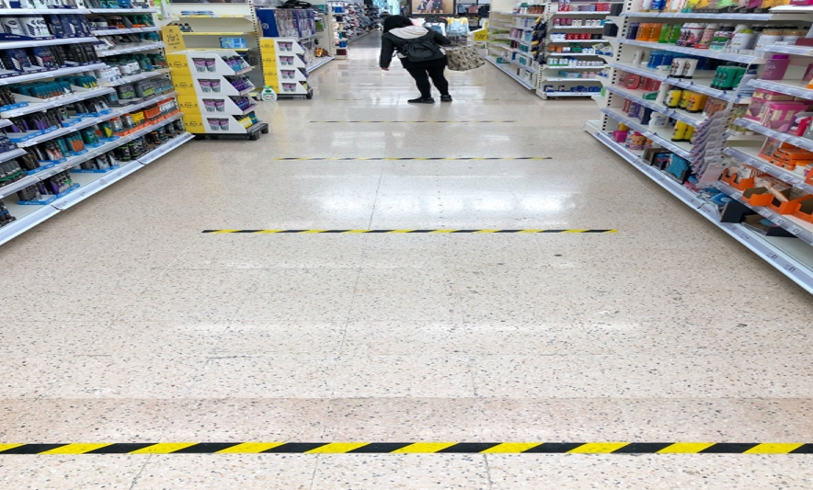

You should not delay while doing your shopping or stop to chat to neighbours, friends or staff.

The checkout worker will tell you when it is safe for you to put your groceries on the belt.

Wash your hands immediately when you get home.

Wash your hands after putting away your groceries and shopping bags.

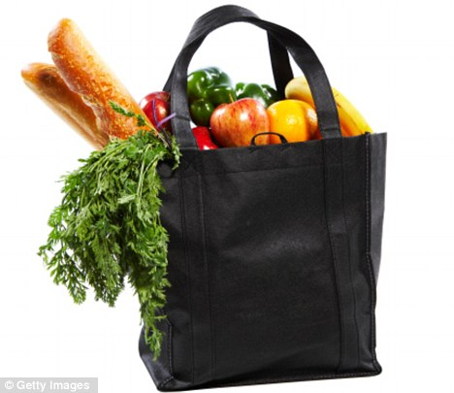

Before going to the supermarket

Contact your local supermarket or look on their website to find a quiet or protected time to visit the store. Explain that autistic people may need more time to process the new information and instructions to shop safely following social distancing measures.

