Stopping at a Garda Checkpoint

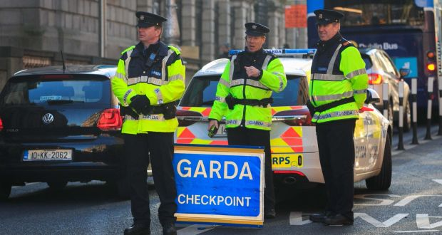

Created by Alisha McMahon, Student Speech and Language Therapist, under the supervision of Michelle O’Donoghue, SLT, CORU reg 018688

How to use a social story™

Social stories™ are short, simple stories that help people to understand what is going on (Gray 2010).
During this pandemic, there has been a lot of change. Social stories are very helpful to understand some of these changes.

Follow these steps when using this social story:

- Read this story before going in the car.

- When possible read this story in a quiet and calm environment.

- Review the story as often as required - some social stories will be reviewed once a day, others just before the situation for which they were written.

- As you get used to the new situation and the story no longer seems necessary, you can phase out the story. For example, you can read it only if you have difficulty understanding a Garda checkpoint to refresh your memory.

- It is a good idea to personalise this social story. The following are examples of how you can do this:
  - Include a picture of the location and what relaxes you.
  - Change the colour of the background on each page to your favourite colour
  - You can customize any page in the social story as long as the message remains consistent

We hope that you enjoy using this social story.

Reference: Gray, C. (2010) The New Social Story™ Book, Future Horizons: Texas.

There is a new virus called the coronavirus. It makes people very sick.

There are new rules to keep everyone safe from the virus.

The Gardaí keep everyone safe. They make sure that everyone is following the new rules.
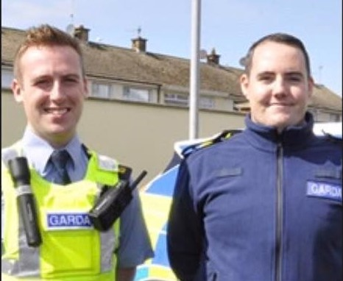

I am going to _insert location here_ in the car.

(Insert picture of location here)

On the way, I see cars stopped on the road.
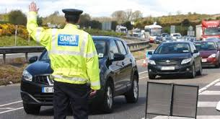
It is a Garda checkpoint.
We are not in trouble.

The Gardaí want to ask questions.

We wait in a queue.
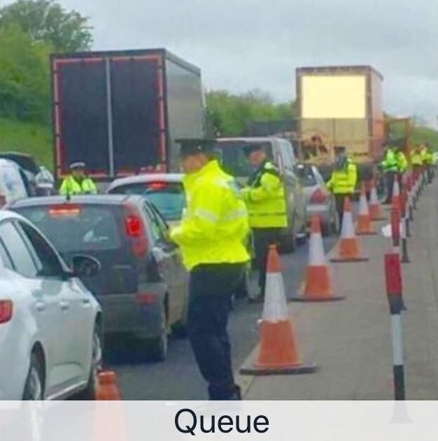

When it is our turn, the driver talks to the Garda.
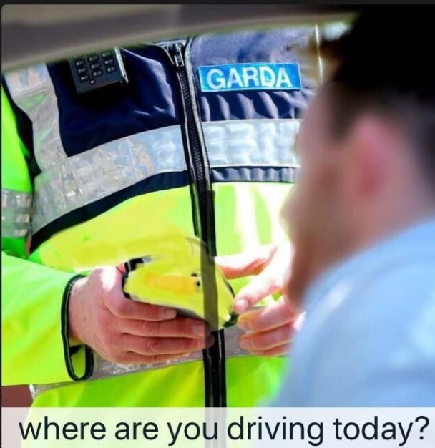

The driver answers questions.

To help me relax, I can…

(Insert what relaxes the person here)

When the driver has answered the Garda’s questions we drive away.

