Stopping at a Garda Checkpoint

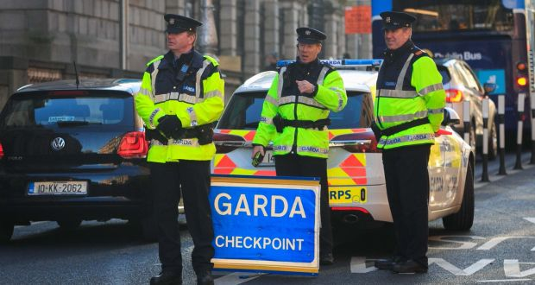

Created by Alisha McMahon, Student Speech and Language Therapist, under the supervision of Michelle O’Donoghue, SLT, CORU reg 018688

How to use a social story™

Social stories™ are short, simple stories that help people to understand what is going on (Gray 2010).
During this pandemic, there has been a lot of change. Social stories are very helpful to understand some of these changes.
Follow these steps when using this social story:
- Read this story before going in the car.

- When possible read this story to your child in a quiet and calm environment.

- Tell your child what you will do, e.g. “This story is about stopping at a Garda checkpoint. Let's read it together”.

- Maintain a positive, reassuring and patient attitude when reviewing the story.

- Review the story as often as required - some social stories will be reviewed once a day, others just before the situation for which they were written.

- As your child gets used to the new situation and the story no longer seems necessary, you can phase out the story. For example, you can read it only when your child is having difficulty understanding a Garda checkpoint to refresh their memory.

- It is a good idea to personalise this social story. The following are examples of how you can do this:
  - Add a picture of the location you are going to
  - Add a picture of what relaxes your child
  - You can customize any page in the social story as long as the message remains consistent

We hope that you enjoy using this social story.

Reference: Gray, C. (2010) The New Social Story™ Book, Future Horizons: Texas.

There is a new virus called the coronavirus that can make people very sick.

There are new rules to help keep everyone safe from the virus.

The Gardaí have an important job. They want to keep everyone safe. They make sure that everyone is following the new rules.

Hi, I am a Garda and sometimes we stop people in the car to check everyone is following the rules to help keep everyone safe.

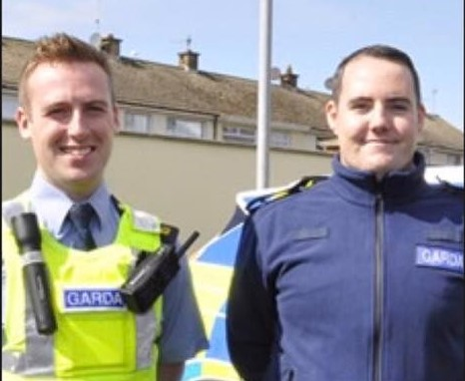

I am going to _(insert location here)_ in the car.

You can add a picture of the location here

*insert picture of your car and the shop you go to here

On the way, I see cars stopped on the road.

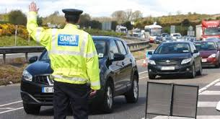

It is a Garda checkpoint.
We are not in trouble.
The Gardaí want to ask questions.

We wait in a queue for our turn to talk to the garda.

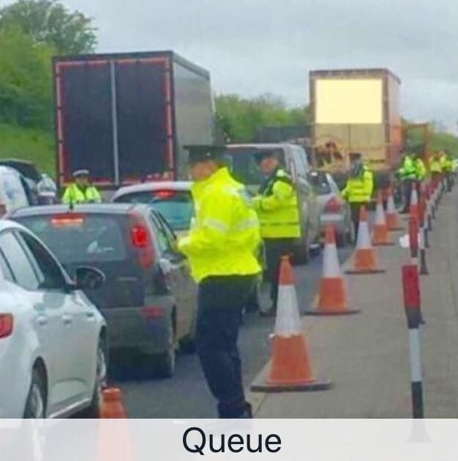

When it is our turn, the driver puts down the window and talks to the Garda.

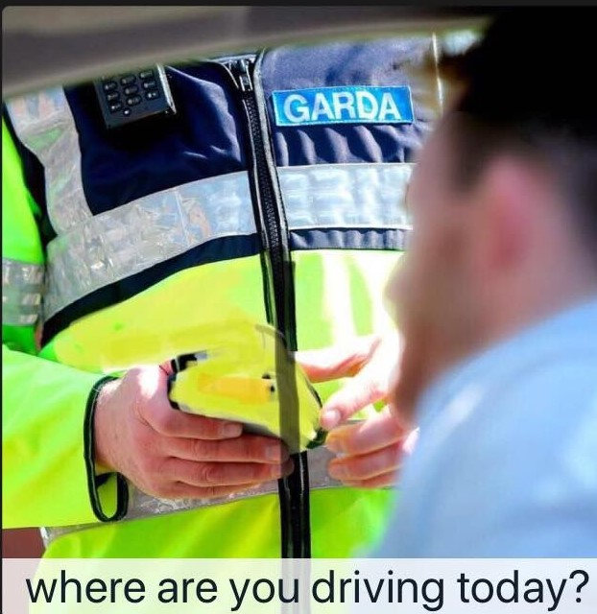

The driver answers the Garda’s questions.
I do not have to answer questions.

If I feel upset, I can try…

(Insert what relaxes your child here).

When the driver has answered the Garda’s questions, we drive away and continue our journey.

